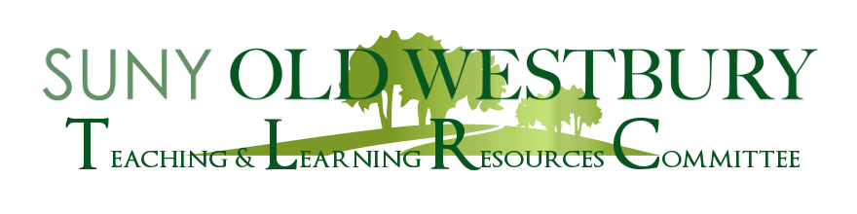

**Roundtable Discussion**

**Teaching Here, There, and Everywhere**

A Panel Discussion featuring:

**Dr. Robert Mevissen, Dr. Yogesh More, and Dean Betty Berbari  
History and Philosophy Math and CIS College of Arts & Sciences**

**Friday, April 29 12:o0 – 1:00pm Virtual (Zoom)**

In what ways might we improve assessing student learning in the pandemic classroom? How can new technology assist in exams and assignments? This roundtable discussion will address all these questions. Robert will present on “How to Hybrid: Flopped to Flipped Classroom,” Yogesh will discuss “Video Killed the Test-taking Star,” and Betty will discuss “Socrates and the Final Exam.”

Join us for an engaging discussion!

Zoom Registration:  <https://suny-ow-edu.zoom.us/meeting/register/tZYuceCgrDkoHt3z7TYM9Ad6H8K0VuESTyL6>